Lab Exercise 1.2 – Permission Set

Step 5: Create a Permission Set
- Go to Setup → Permission Sets → New.
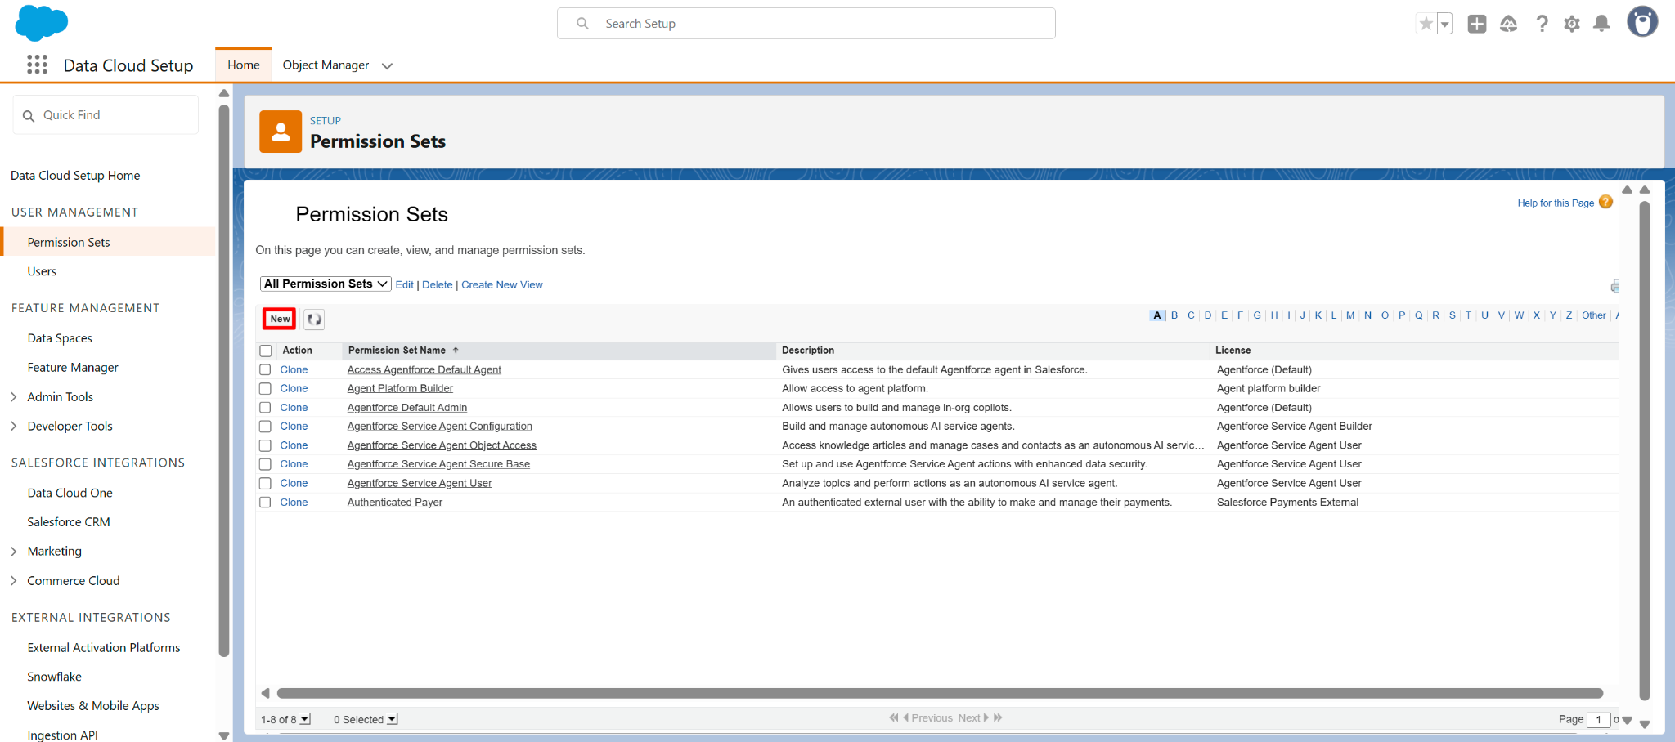
- Enter the label ‘Data Cloud Learner’ , API name 'Data_Cloud_Learner' and description ‘Minimal access’ save.
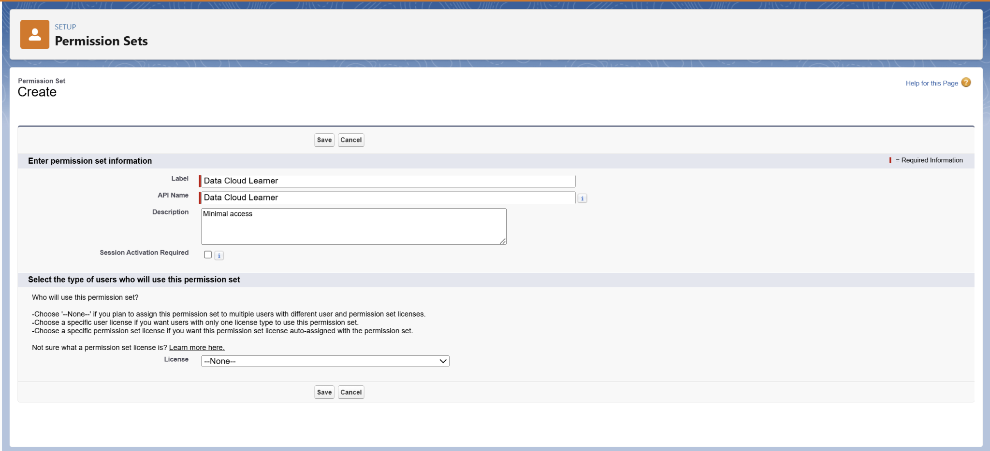
- 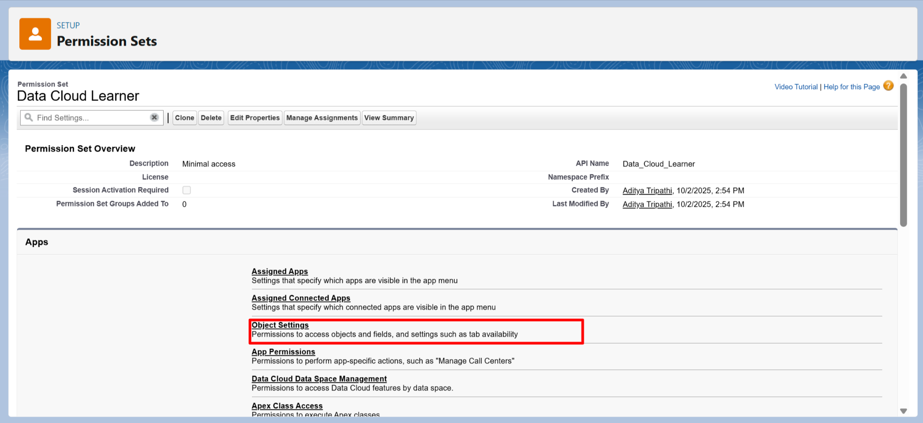
- Assigning Minimal Access. You should look for and assign Read access to following key Data Cloud objects.
  - Data Streams
  - Data Models Object
  - Data Lake Object
  - Segments
  - Individuals

- Find the Object: On the Object Settings page
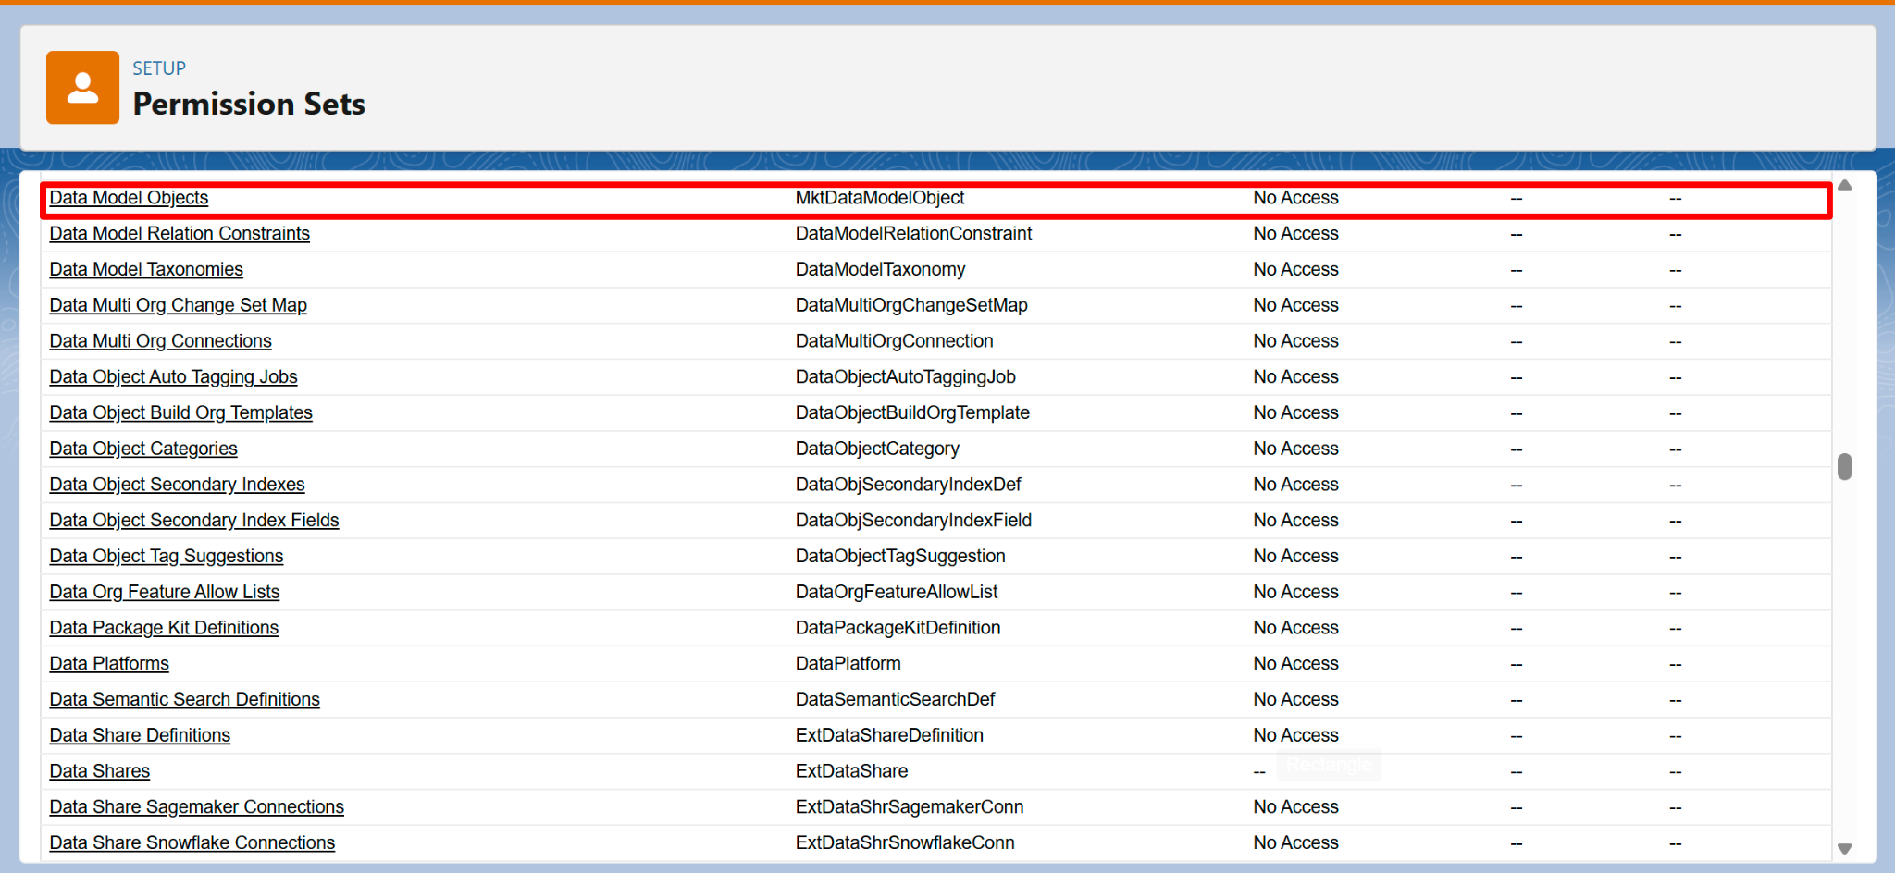
- Click to Edit
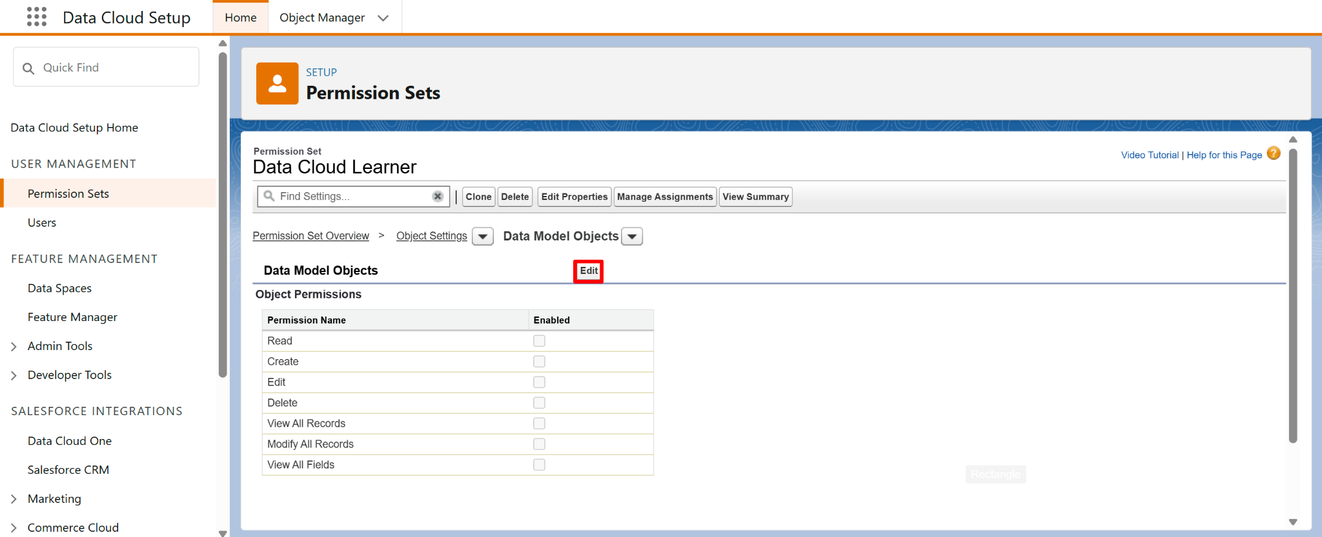
- Under Object Permissions, check Read and Click Save.
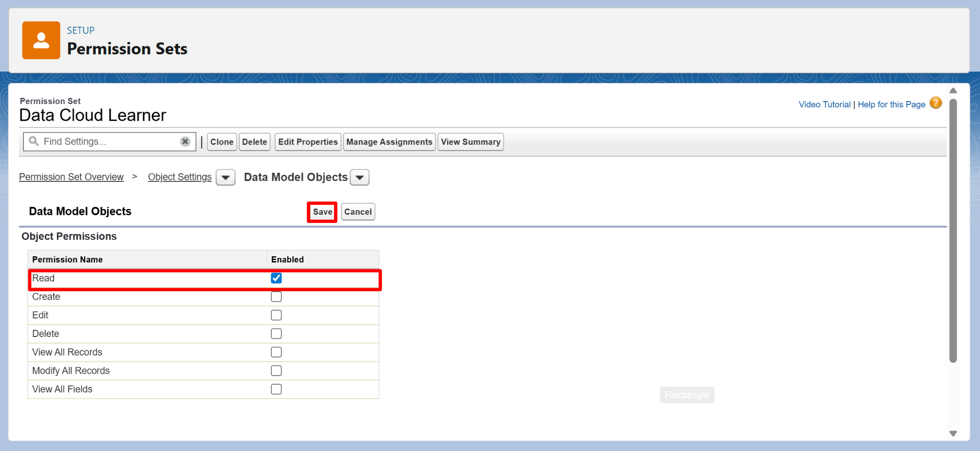
- Like the above Data Object Enable Read permission to other objects.
Note: In the Segments object under the Tab Settings section, check the Visible box for Available (you may only see one checkbox) and Click Save.
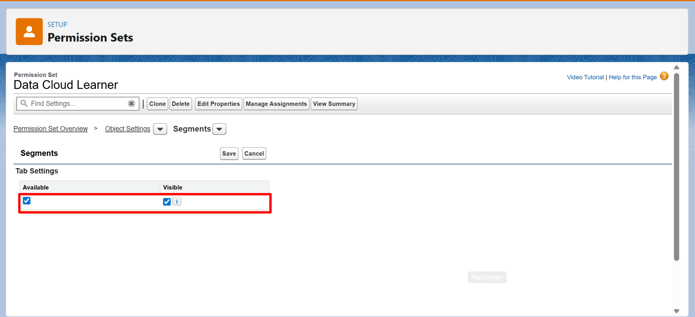

- In System Permissions, enable minimal access:
- Assign this Permission Set to your user.

Step 6: Review and Compare Access
- Open your User record (Setup → Users →Users → [Your Name]).
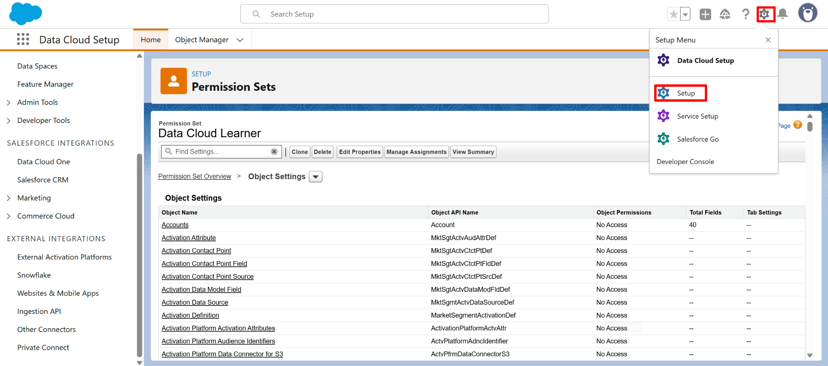
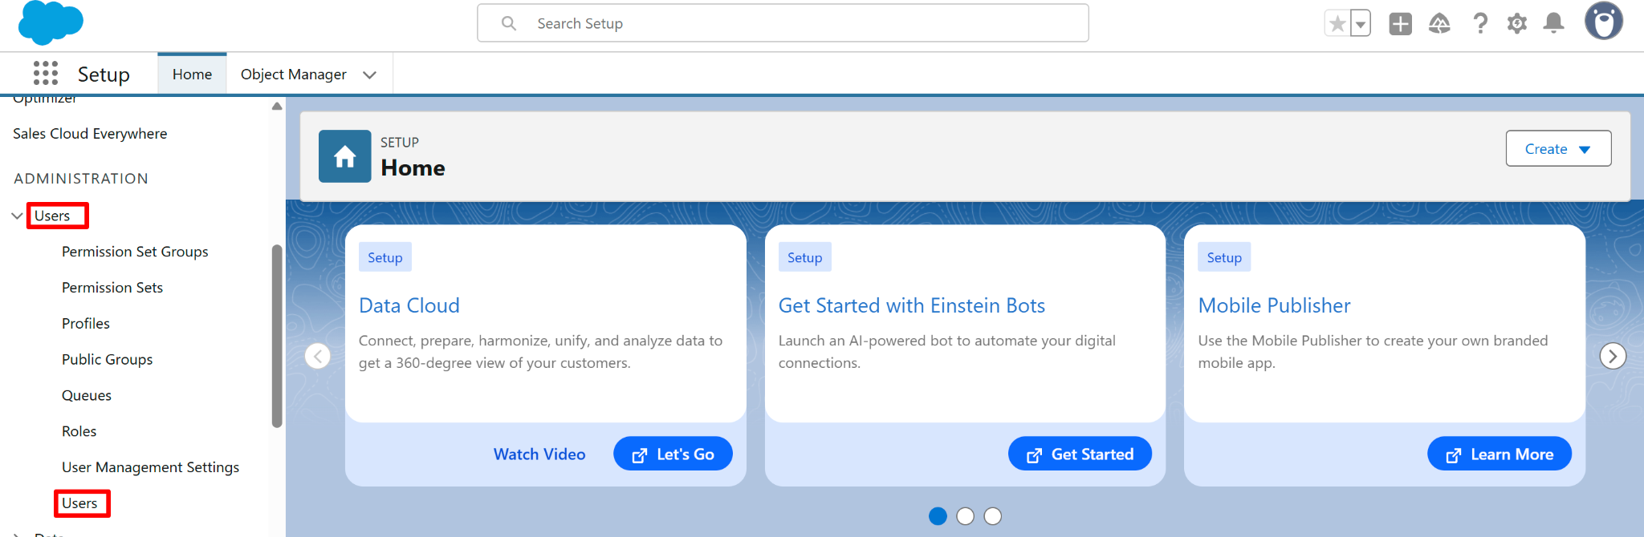
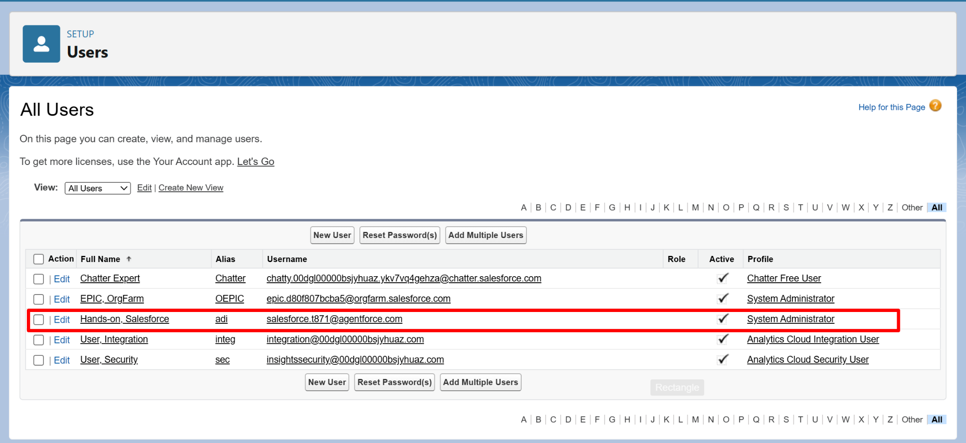
- What your Profile provides
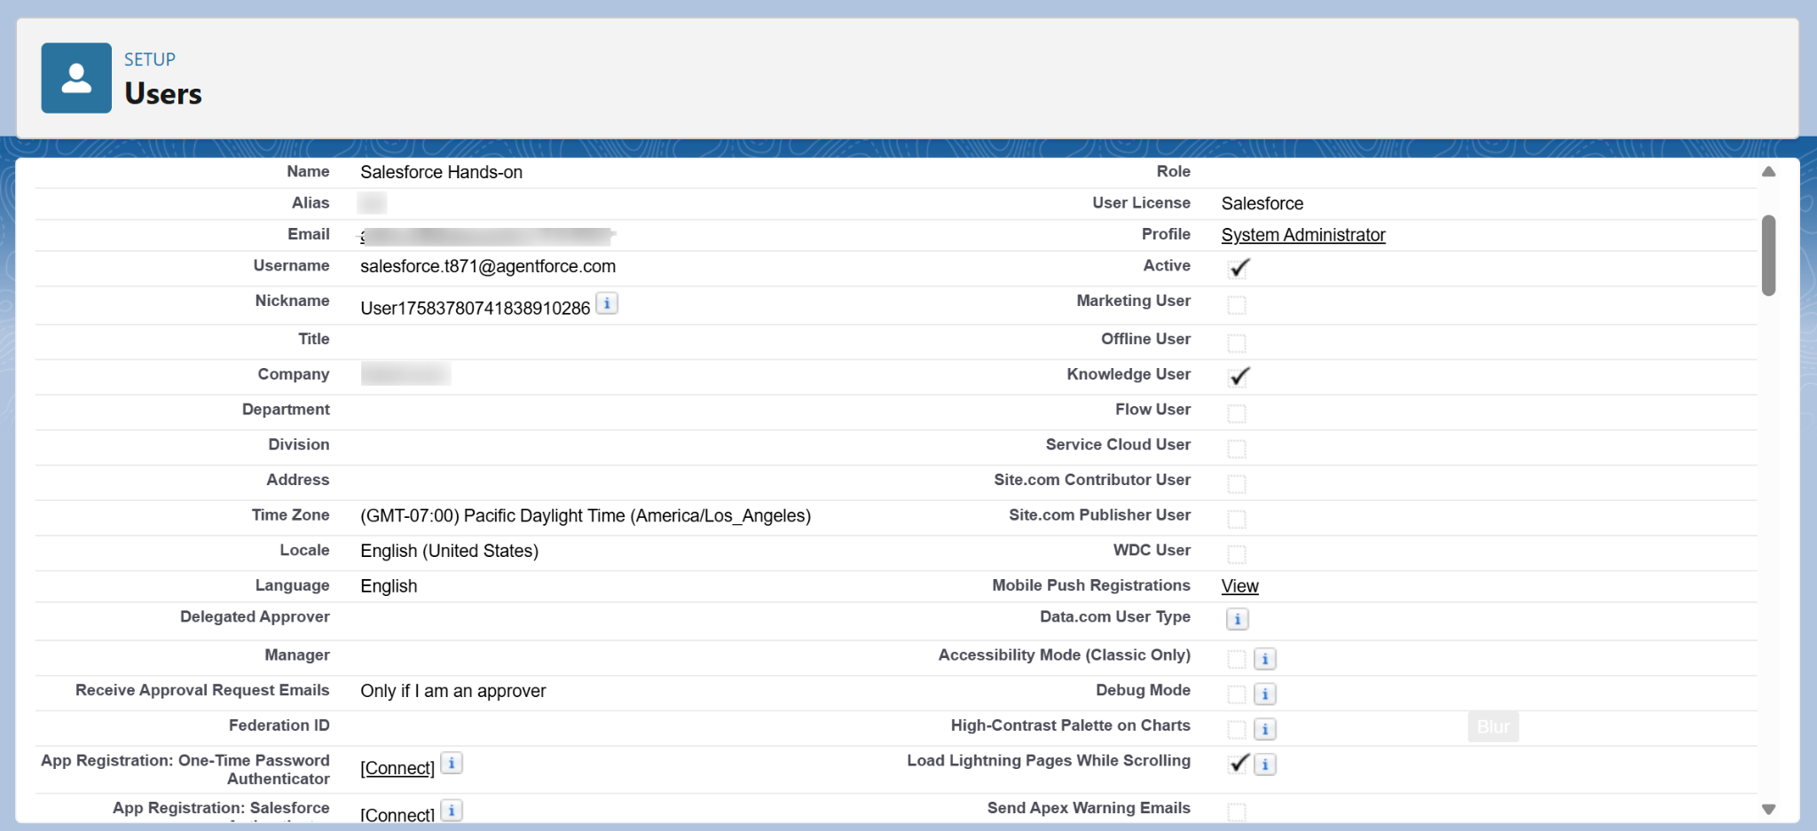
What the Permission Set adds.

